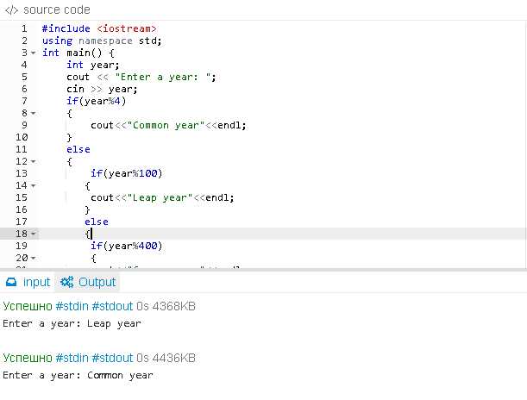

Lab. 2.1(1)

#include <iostream>

using namespace std;

int main() {

int year;

cout << "Enter a year: ";

cin >> year;

if(year%4)

{

cout<<"Common year"<<endl;

}

else

{

if(year%100)

{

cout<<"Leap year"<<endl;

}

else

{

if(year%400)

{

cout<<"Common year"<<endl;

}

else

{

cout<<"Leap year"<<endl;

}

}

}

return 0;

}

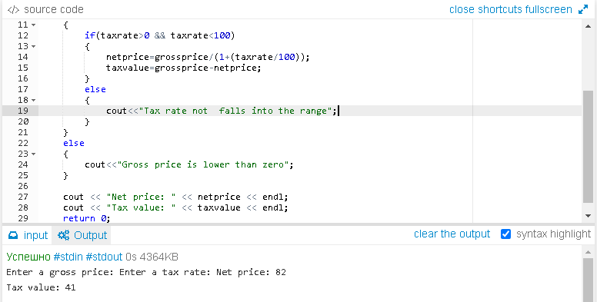

Lab.2.1(2)

#include<iostream>

using namespace std;

int main(void)

{

float grossprice, taxrate, netprice, taxvalue;

cout << "Enter a gross price: ";

cin >> grossprice;

cout << "Enter a tax rate: ";

cin >> taxrate;

if(grossprice>0)

{

if(taxrate>0 && taxrate<100)

{

netprice=grossprice/(1+(taxrate/100));

taxvalue=grossprice-netprice;

}

else

{

cout<<"Tax rate not falls into the range";

}

}

else

{

cout<<"Gross price is lower than zero";

}

cout << "Net price: " << netprice << endl;

cout << "Tax value: " << taxvalue << endl;

return 0;

}

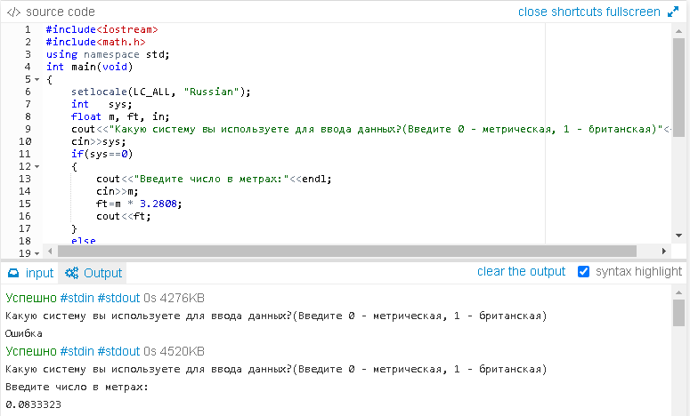

Lab.2.1(3)

#include<iostream>

#include<math.h>

using namespace std;

int main(void)

{

setlocale(LC_ALL, "Russian");

int sys;

float m, ft, in;

cout<<"Какую систему вы используете для ввода данных?(Введите 0 - метрическая, 1 - британская)"<<endl;

cin>>sys;

if(sys==0)

{

cout<<"Введите число в метрах:"<<endl;

cin>>m;

ft=m * 3.28084;

in = (ft - floor(ft)) * 12;

cout << floor(ft) << "`" << in << "``";

}

else

{

if(sys==1)

{

cout<<"Введите число в дюймах и футах:"<<endl;

cin>>ft;

cin>>in;

m = in / 39.370078 + ft / 3.28084;

cout<<m;

}

else

{

cout<<"Ошибка";

}

}

return 0;

}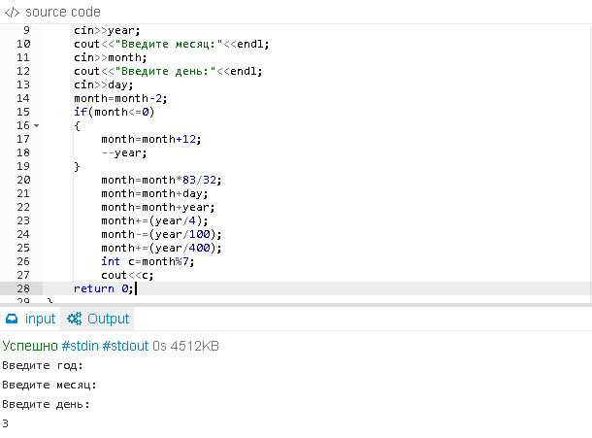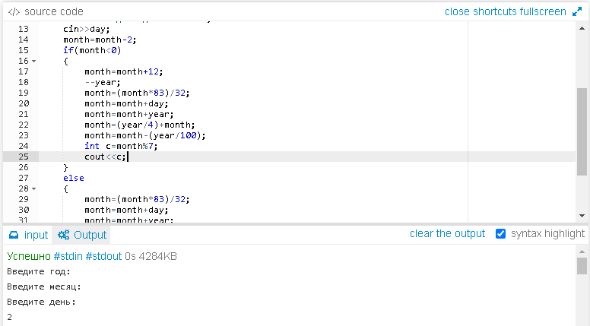

Lab.2.1(4)

#include<iostream>

#include<math.h>

using namespace std;

int main(void)

{

setlocale(LC_ALL, "Russian");

int year, month, day;

cout<<"Введите год:"<<endl;

cin>>year;

cout<<"Введите месяц:"<<endl;

cin>>month;

cout<<"Введите день:"<<endl;

cin>>day;

month=month-2;

if(month<=0)

{

month=month+12;

--year;

}

month=month*83/32;

month=month+day;

month=month+year;

month+=(year/4);

month-=(year/100);

month+=(year/400);

int c=month%7;

cout<<c;

return 0;

}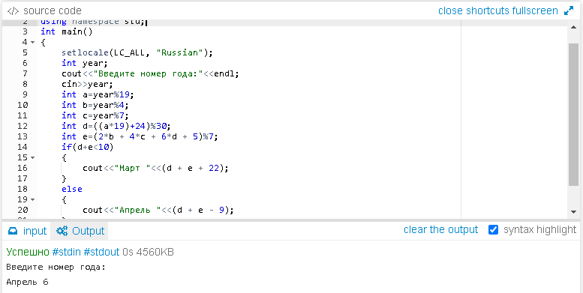

Lab. 2.1(5)

#include <iostream>

using namespace std;

int main()

{

setlocale(LC_ALL, "Russian");

int year;

cout<<"Введите номер года:"<<endl;

cin>>year;

int a=year%19;

int b=year%4;

int c=year%7;

int d=((a*19)+24)%30;

int e=(2*b + 4*c + 6*d + 5)%7;

if(d+e<10)

{

cout<<"Март "<<(d + e + 22);

}

else

{

cout<<"Апрель "<<(d + e - 9);

}

return 0;

}

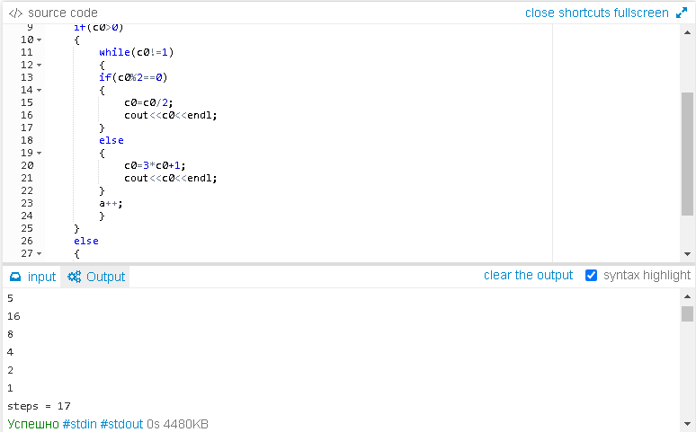

Lab.2.3(1)

#include <iostream>

using namespace std;

int main()

{

setlocale(LC_ALL, "Russian");

int c0,a=0;

cout<<"Введите число"<<endl;

cin>>c0;

if(c0>0)

{

while(c0!=1)

{

if(c0%2==0)

{

c0=c0/2;

cout<<c0<<endl;

}

else

{

c0=3*c0+1;

cout<<c0<<endl;

}

a++;

}

}

else

{

cout<<"Ошибка";

}

cout<<"steps = "<<a;

return 0;

}

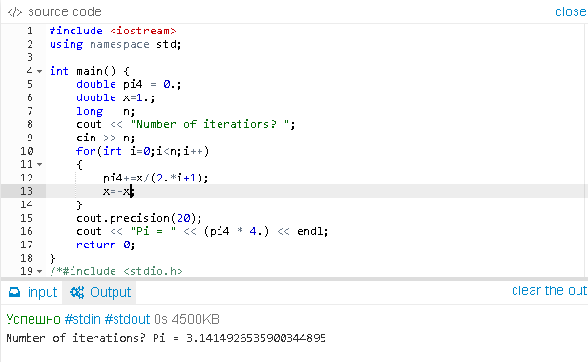

Lab.2.3(2)

#include <iostream>

using namespace std;

int main() {

double pi4 = 0.;

double x=1.;

long n;

cout << "Number of iterations? ";

cin >> n;

for(int i=0;i<n;i++)

{

pi4+=x/(2.*i+1);

x=-x;

}

cout.precision(20);

cout << "Pi = " << (pi4 * 4.) << endl;

return 0;

}

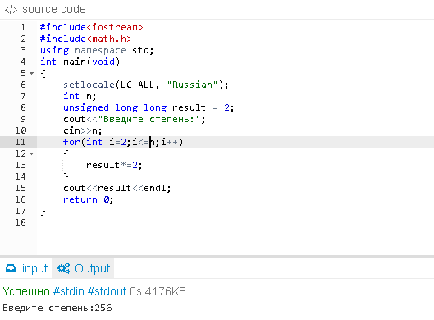

Lab.2.3(3)

#include<iostream>

#include<math.h>

using namespace std;

int main(void)

{

setlocale(LC_ALL, "Russian");

int n;

unsigned long long result = 2;

cout<<"Введите степень:";

cin>>n;

for(int i=2;i<=n;i++)

{

result*=2;

}

cout<<result<<endl;

return 0;

}

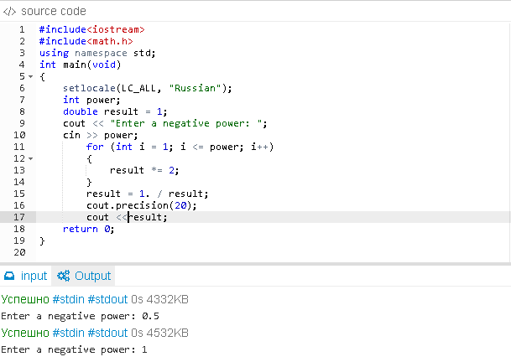

Lab.2.3(4)

#include<iostream>

#include<math.h>

using namespace std;

int main(void)

{

setlocale(LC_ALL, "Russian");

int power;

double result = 1;

cout << "Enter a negative power: ";

cin >> power;

for (int i = 1; i <= power; i++)

{

result *= 2;

}

result = 1. / result;

cout.precision(20);

cout <<result;

return 0;

}

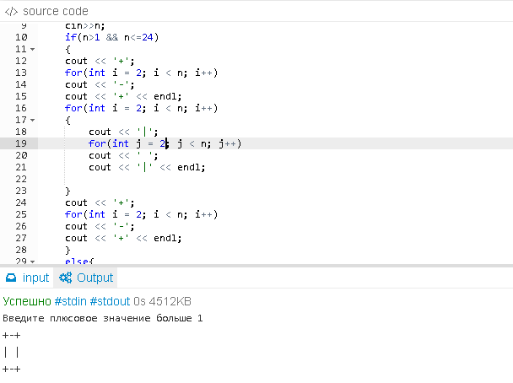

Lab.2.3(5)

#include<iostream>

#include<math.h>

using namespace std;

int main(void)

{

setlocale(LC_ALL, "Russian");

int n;

cout<<"Введите плюсовое значение больше 1"<<endl;

cin>>n;

if(n>1 && n<=24)

{

cout << '+';

for(int i = 2; i < n; i++)

cout << '-';

cout << '+' << endl;

for(int i = 2; i < n; i++)

{

cout << '|';

for(int j = 2; j < n; j++)

cout << ' ';

cout << '|' << endl;

}

cout << '+';

for(int i = 2; i < n; i++)

cout << '-';

cout << '+' << endl;

}

else{

if(n>24)

cout<<"Ошибка";

}

return 0;

}

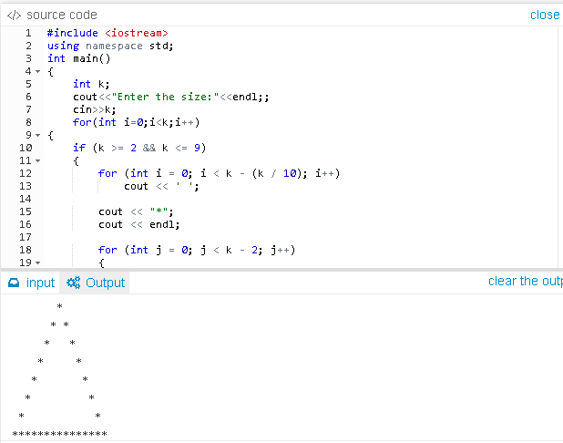

Lab.2.3(6)

#include <iostream>

using namespace std;

int main()

{

int k;

cout<<"Enter the size:"<<endl;;

cin>>k;

for(int i=0;i<k;i++)

{

if (k >= 2 && k <= 9)

{

for (int i = 0; i < k - (k / 10); i++)

cout << ' ';

cout << "*";

cout << endl;

for (int j = 0; j < k - 2; j++)

{

for (int i = 1; i < k - j; i++)

cout << ' ';

cout << '*';

for (int x = k - 2 * j; x <= k; x++)

cout << ' ';

cout << '*';

cout << endl;

}

double a;

a = k * 1.6;

if (k > 2 && k < 6)

a += 1;

if (k > 5 && k < 8)

a += 2;

if (k > 7 && k <= 9)

{

a += 3;

}

cout << " ";

for (int j = 1; j < a; j++)

{

cout << "*";

}

}

else

cout << "Error";

cout << endl;

}

return 0;

}

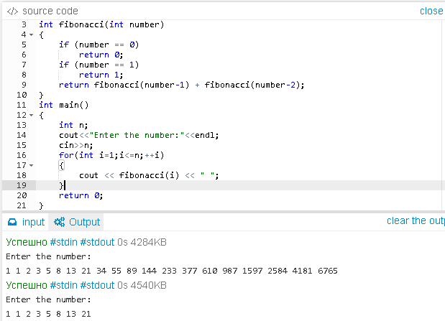

Lab.2.3(7)

#include <iostream>

using namespace std;

int fibonacci(int number)

{

if (number == 0)

return 0;

if (number == 1)

return 1;

return fibonacci(number-1) + fibonacci(number-2);

}

int main()

{

int n;

cout<<"Enter the number:"<<endl;

cin>>n;

for(int i=1;i<=n;++i)

{

cout << fibonacci(i) << " ";

}

return 0;

}

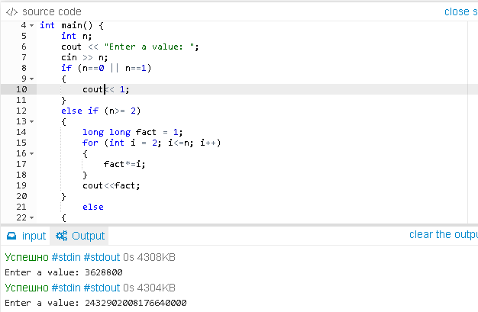

Lab.2.3(8)

#include <iostream>

using namespace std;

int main() {

int n;

cout << "Enter a value: ";

cin >> n;

if (n==0 || n==1)

{

cout<< 1;

}

else if (n>= 2)

{

long long fact = 1;

for (int i = 2; i<=n; i++)

{

fact*=i;

}

cout<<fact;

}

else

{

cout <<"Error";

}

return 0;

}

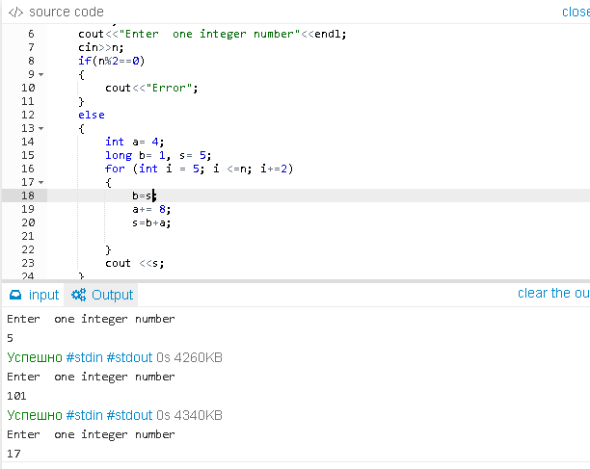

Lab.2.3(9)

#include <iostream>

using namespace std;

int main() {

int n;

cout<<"Enter one integer number"<<endl;

cin>>n;

if(n%2==0)

{

cout<<"Error";

}

else

{

int a= 4;

long b= 1, s= 5;

for (int i = 5; i <=n; i+=2)

{

b=s;

a+= 8;

s=b+a;

}

cout <<s;

}

return 0;

}

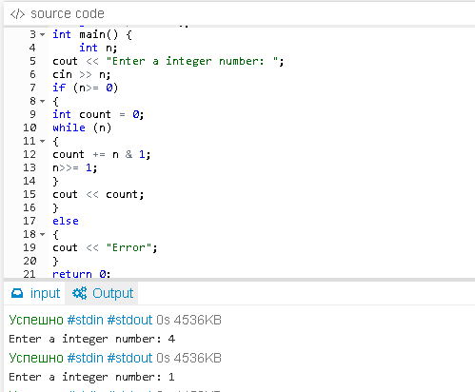

Lab.2.4(1)

#include <iostream>

using namespace std;

int main() {

int n;

cout << "Enter a integer number: ";

cin >> n;

if (n>= 0)

{

int count = 0;

while (n)

{

count += n & 1;

n>>= 1;

}

cout << count;

}

else

{

cout << "Error";

}

return 0;

}

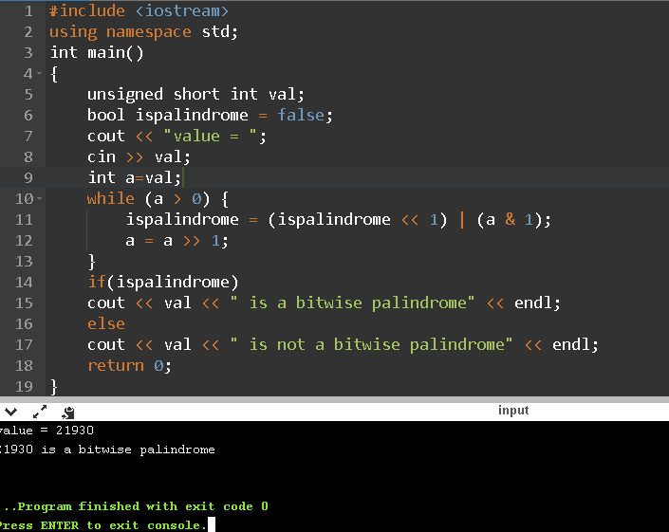

Lab. 2.4(2)

#include <iostream>

using namespace std;

int main()

{

unsigned short int val;

bool ispalindrome = false;

cout << "value = ";

cin >> val;

int a=val;

while (a > 0) {

ispalindrome = (ispalindrome << 1) | (a & 1);

a = a >> 1;

}

if(ispalindrome)

cout << val << " is a bitwise palindrome" << endl;

else

cout << val << " is not a bitwise palindrome" << endl;

return 0;

}

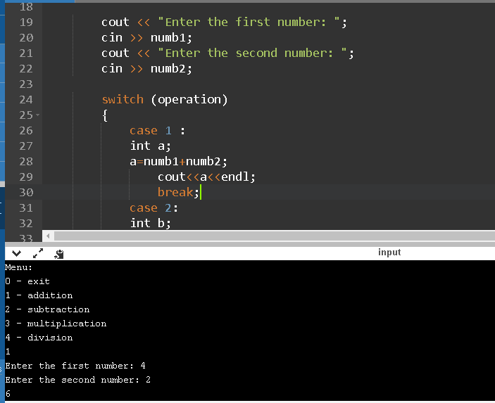

Lab. 2.5

#include <iostream>

using namespace std;

int main()

{

int operation;

float numb1, numb2;

cout << "Menu:\n0 - exit \n1 - addition \n2 - subtraction \n3 - multiplication \n4 - division"<<endl;

cin >> operation;

while (operation != 0)

{

if (operation < 0 || operation >= 5)

{

cout<<"You entered incorrect operation";

continue;

}

cout << "Enter the first number: ";

cin >> numb1;

cout << "Enter the second number: ";

cin >> numb2;

switch (operation)

{

case 1 :

int a;

a=numb1+numb2;

cout<<a<<endl;

break;

case 2:

int b;

b=numb1-numb2;

cout<<b<<endl;

break;

case 3:

int c;

c=numb1 * numb2;

cout<<c<<endl;

break;

case 4:

if(numb2==0)

cout<<"Error";

else {

int e;

e=numb1 / numb2;

cout<<e<<endl;

}

break;

default:

cout<<"You entered invalid operation";

}

cout << "Menu:\n0 - exit \n1 - addition \n2 - subtraction \n3 - multiplication \n4 - division"<<endl;

cin >> operation;

}

return 0;

}

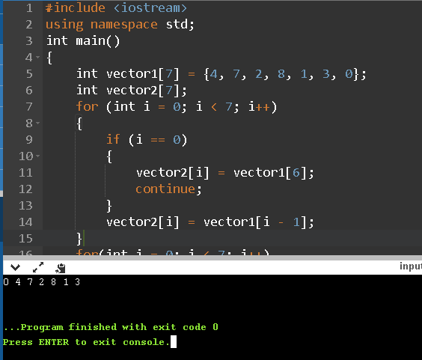

Lab. 2.9(1)

#include <iostream>

using namespace std;

int main()

{

int vector1[7] = {4, 7, 2, 8, 1, 3, 0};

int vector2[7];

for (int i = 0; i < 7; i++)

{

if (i == 0)

{

vector2[i] = vector1[6];

continue;

}

vector2[i] = vector1[i - 1];

}

for(int i = 0; i < 7; i++)

cout << vector2[i] << ' ';

cout << endl;

return 0;

}

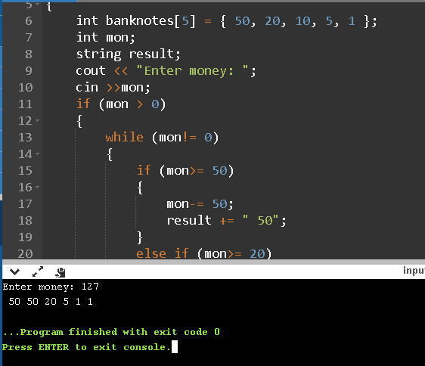

Lab. 2.9(2)

#include <iostream>

#include <string>

using namespace std;

int main()

{

int banknotes[5] = { 50, 20, 10, 5, 1 };

int mon;

string result;

cout << "Enter money: ";

cin >>mon;

if (mon > 0)

{

while (mon!= 0)

{

if (mon>= 50)

{

mon-= 50;

result += " 50";

}

else if (mon>= 20)

{

mon-= 20;

result += " 20";

}

else if (mon>= 10)

{

mon-= 10;

result += " 10";

}

else if (mon>= 5)

{

mon-= 5;

result += " 5";

}

else

{

mon-= 1;

result += " 1";

}

}

cout << result;

}

else

{

cout << "Error";

}

return 0;

}

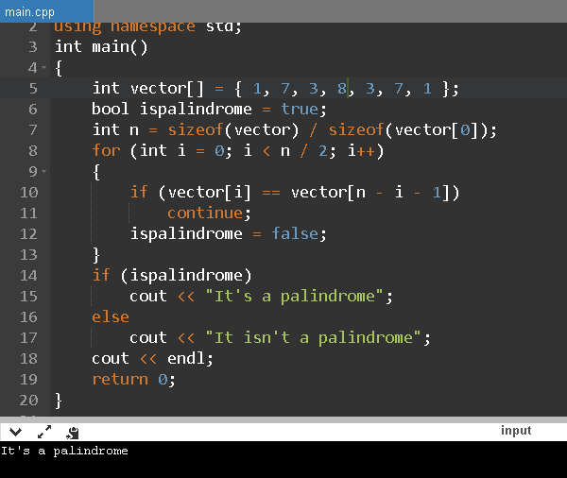

Lab. 2.9(3)

#include <iostream>

using namespace std;

int main()

{

int vector[] = { 1, 7, 3, 8, 3, 7, 1 };

bool ispalindrome = true;

int n = sizeof(vector) / sizeof(vector[0]);

for (int i = 0; i < n / 2; i++)

{

if (vector[i] == vector[n - i - 1])

continue;

ispalindrome = false;

}

if (ispalindrome)

cout << "It's a palindrome";

else

cout << "It isn't a palindrome";

cout << endl;

return 0;

}

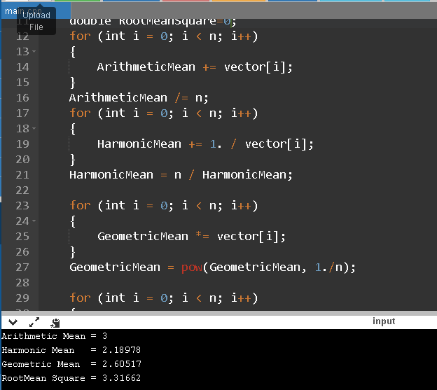

Lab. 2.9(4)

#include<iostream>

#include<cmath>

using namespace std;

int main(void)

{

double vector[] = { 1., 2., 3., 4., 5. };

int n = sizeof(vector) / sizeof(vector[0]);

double ArithmeticMean=0;

double HarmonicMean=0;

double GeometricMean=1;

double RootMeanSquare=0;

for (int i = 0; i < n; i++)

{

ArithmeticMean += vector[i];

}

ArithmeticMean /= n;

for (int i = 0; i < n; i++)

{

HarmonicMean += 1. / vector[i];

}

HarmonicMean = n / HarmonicMean;

for (int i = 0; i < n; i++)

{

GeometricMean *= vector[i];

}

GeometricMean = pow(GeometricMean, 1./n);

for (int i = 0; i < n; i++)

{

RootMeanSquare += pow(vector[i], 2);

}

RootMeanSquare = RootMeanSquare / n;

RootMeanSquare = pow(RootMeanSquare, 1./2);

cout << "Arithmetic Mean = " << ArithmeticMean << endl;

cout << "Harmonic Mean = " << HarmonicMean << endl;

cout << "Geometric Mean = " << GeometricMean << endl;

cout << "RootMean Square = " << RootMeanSquare << endl;

cout << endl;

return 0;

}

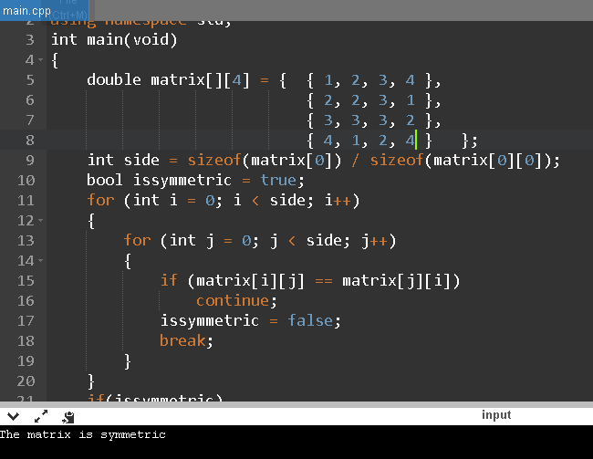

Lab. 2.9(5)

#include<iostream>

using namespace std;

int main(void)

{

double matrix[][4] = { { 1, 2, 3, 4 },

{ 2, 2, 3, 1 },

{ 3, 3, 3, 2 },

{ 4, 1, 2, 4 } };

int side = sizeof(matrix[0]) / sizeof(matrix[0][0]);

bool issymmetric = true;

for (int i = 0; i < side; i++)

{

for (int j = 0; j < side; j++)

{

if (matrix[i][j] == matrix[j][i])

continue;

issymmetric = false;

break;

}

}

if(issymmetric)

cout << "The matrix is symmetric" << endl;

else

cout << "The matrix is not symmetric" << endl;

return 0;

}